1. s1:
2. When doing relational mapping, can add more constraint to the given schema

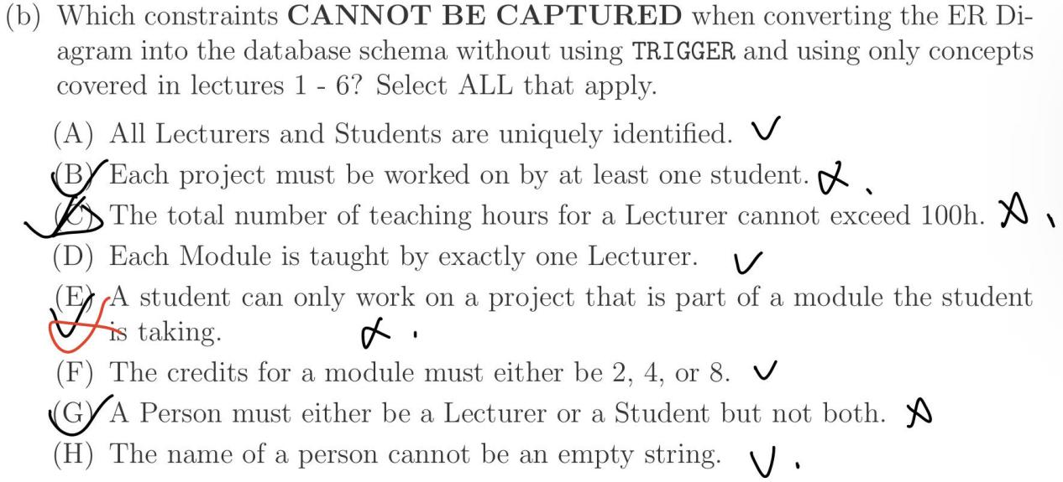

1. SELECT COUNT(smth)

WHERE ...

这里的COUNT(), 在WHERE clause 筛选结束了以后，COUNT筛选过后的table里的行数

1. s1:
2. 注意看题里给的schema
3. When doing NATURAL JOIN, but there is no common attributes => Then it is same as doing cross product.
4. LEFT JOIN要注意右边的范围，不能LEFT JOIN到最大的Set：而是具体题干里的Set
5. s2:
6. Foreign key can only refer to the primary key in the referenced table, though psql also allows it to refer to unique not null.
7. For each entity set, the key attribute must uniquely identify rest of attributes which are **in the same table** after relational mapping.
8. 注意考虑When COUNT(smth) evaluates to 0的情况；以及如果一个table是empty，另一个table的情况

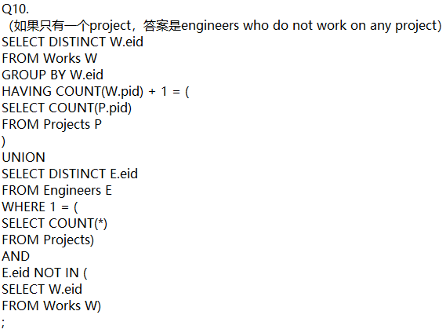

1. s1:
2. Cardinality / Double negation:

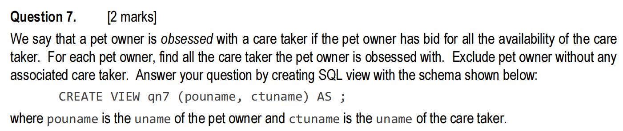

1. s2:
2. WHERE EXISTS (...)

GROUP BY ...

这里的EXISTS针对每一行，不能针对GROUP

1. Double Negation解决for every的情况:

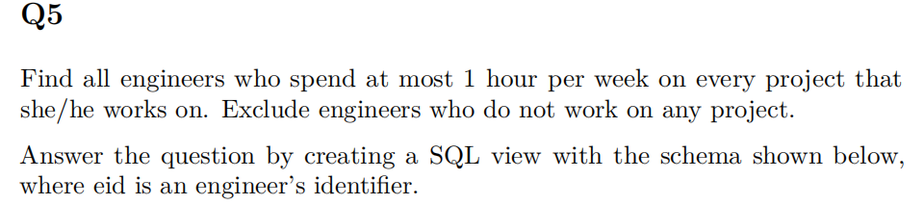

Same as: There is no project, on which the engineer spend more than 1 hour

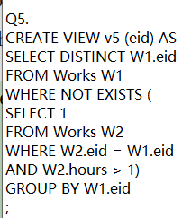

1. 用Cardinality解决for every的情况：
   1. R and S = R
2. GROUP BY之前用WHERE EXISTS检查每一行，筛选出符合条件的

A里满足条件的行数 = A的全部行数

* 1. R union S = R

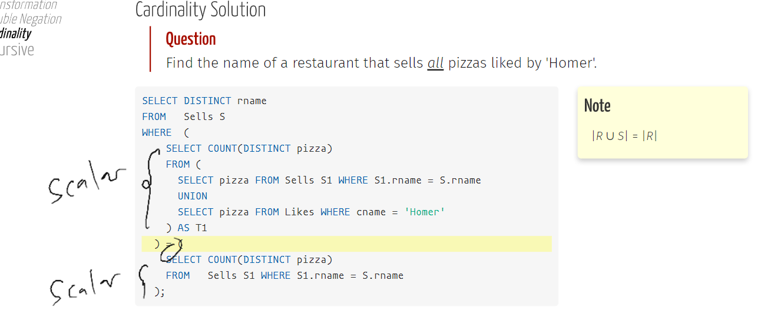

1. =和IN的区别:

= 的subquery只能return一个值，不然error

